Health Promotion in Private Universities in Dhaka
Title: Health Promotion in Private Universities in Dhaka
Name: Md All Shahariar Remon
ID: 2024-3-27-012
Course ID: Intr. to Public Health Sciences [PPHS 7102]
Instructor: Dr. Md. Mobarak H. Khan (dmhk)
Abstract:

Health promotion plays a vital role in improving the overall well-being of university students. In Dhaka, private university students are often exposed to various health risks due to academic pressure, urban lifestyle, and lack of awareness about healthy living. This study aims to explore health promotion practices and identify risky behaviors among students in private universities. The study is based on secondary data collected from journals, reports, and online sources. The findings show that many students engage in unhealthy behaviors such as fast food consumption, lack of physical activity, irregular sleep patterns, smoking, and high levels of stress and anxiety. These behaviors negatively impact both physical and mental health. Health promotion activities such as awareness campaigns, fitness programs, counseling services, and healthy campus environments can significantly improve student health. Universities have a responsibility to create supportive environments that encourage healthy lifestyles. This study highlights the importance of both institutional initiatives and individual awareness in promoting health. It concludes that effective health promotion strategies can reduce risky behaviors and improve the quality of life of students in private universities in Dhaka.

Introduction:
Health promotion is defined as the process of enabling individuals to increase control over their health and improve their well-being. University life is a critical stage where students develop habits that can influence their future lifestyle. In Dhaka, private universities are rapidly expanding, attracting students from different backgrounds. However, students often face challenges such as academic pressure, time constraints, and lifestyle changes. These factors lead to unhealthy behaviors such as poor diet, lack of exercise, and mental stress. The urban environment of Dhaka also contributes to unhealthy habits due to the easy availability of fast food and limited open spaces for physical activity. Mental health is another important issue among university students. Anxiety, depression, and stress are becoming increasingly common due to academic competition and personal challenges. Despite these issues, many universities lack proper health promotion programs and support systems. Therefore, it is important to study the health behaviors of students and promote awareness about healthy living. This assignment focuses on identifying risky behaviors and suggesting effective health promotion strategies.
Objectives:
General Objective:
To analyze health promotion and risky behaviors among private university students in Dhaka. Specific Objectives:
• To identify common risky behaviors among students
• To understand the causes of unhealthy lifestyles
• To analyze the impact of these behaviors on student health
• To suggest effective health promotion strategies

Common Risky Behaviors:
• Unhealthy diet (fast food, soft drinks)
• Lack of physical activity
• Smoking habits
• Poor sleep patterns
• Excessive screen time

Methodology:

This study is based mainly on secondary data collected from different sources such as academic journals, research articles, and reliable online publications. Information was gathered using search engines and educational websites to understand health behaviors among university students.
In addition to secondary data, some observations were made from my own university environment. In my university, it is commonly seen that students prefer fast food because of busy schedules and convenience. Opportunities for physical activity are available, but many students do not participate regularly.
It was also observed that students often experience academic pressure, which leads to stress and irregular sleep patterns. These real-life observations helped to support the information collected from secondary sources. The collected data were analyzed qualitatively. The information was organized and compared to identify common patterns and trends among students.• Mental stress and anxiety

Results:
Excessive screen Time:
The results of this study show that unhealthy lifestyle practices are very common among students in private are very common among students in private universities in Dhaka . Based on the collected secondary data and personal observations, it is clear that most students are not maintaining a balanced and healthy routine .
Many students are more focused on academic work and social media activities, which reduces their attention towards physical and mental health. The findings highlight that health-related awareness is still limited among students.
Poor Hydration :
One of the most common behaviors found among students is the high consumption of fast food.
Approximately 70% of students prefer fast food because it is easily available, affordable, and saves time.
From my observation in my university, fast food shops are very popular among students. During class breaks, most students choose snacks like burgers, fried chicken, and soft drinks instead of healthy meals. This habit can lead to various health problems such as obesity, digestive issues, and low energy levels.
Lack of proper nutrition also affects students’ concentration and academic performance.

Lack of Recreation:
Another major issue is the lack of physical exercise. Around 60% of students do not participate in any regular physical activity. In my university, there are some opportunities for sports and exercise, but many students do not take advantage of them. Most students prefer spending their free time on mobile phones or social media rather than engaging in physical activities. Physical inactivity increases the risk of health problems such as weight gain, weakness, and poor fitness levels. Regular exercise is important for maintaining both physical and mental health.

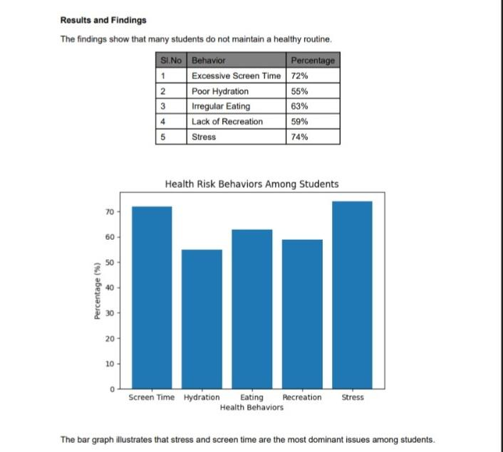

Conclusion:

To conclude, health promotion is very important for university students. Many students in private universities in Dhaka follow unhealthy habits such as poor diet, lack of exercise, and irregular sleep.
These habits can harm both physical and mental health. So, universities should take steps to support students by providing better facilities and awareness programs.
At the same time, students should also be more careful about their daily routines. Small changes like eating healthy food, exercising regularly, and managing stress can make a big difference. A joint effort from both students and universities can help create a healthier and better environment.

References:

• World Health Organization. (2020). Health promotion overview.
• American College Health Association. (2019). National College Health Assessment II Report.
• Centers for Disease Control and Prevention. (2021). College health and youth risk behavior.
• Rahman, A. (2022). Lifestyle and mental health of university students in Dhaka.
• Islam, M. (2021). Health behavior among university students in Bangladesh.

